Appropriate Assessment Screening for installation and operation of a bedload sediment trap in the Mulkear Catchment, Co. Limerick

Document Verification
Project Title: | Appropriate Assessment Screening for installation and operation of a bedload sediment trap in the Mulkear Catchment, Co. Limerick |  |  | Project No.:
Report Title: | Appropriate Assessment Screening Report
Document No.: | 0.1
Prepared By: | Aline O’Connell
Checked By: | John Baggott
Revision 1.1 | Date 26/08/2026

QI Qualifying Interests

SAC Special Areas of Conservation

SPA Special Protection Areas

Table of Contents
2 Introduction 2
3 Legislative Context for this report 3
3.1 Requirement for Appropriate Assessment 3
3.2 Structure / Layout of the report 3
3.3 Main Sources of Consultation and Information 3
4 Description and Features of the Area and Project 5
4.1 Introduction 5
4.2 Screening Methodology 6
4.3 Project description 8
5 Screening for Appropriate Assessment: European (Natura 2000) Sites and the Potential for Significant Effects 17
5.1 Screening Assessment of Natura 2000 Sites 17
5.2 Assessment of Potential Impact on European Sites to installation of two river bed traps (temporally works) 21
4.3 Cumulative and in-combination Impacts 32
5 CONCLUSION 34
6 Appendix A – Bedload sediments trap 35
7 Appendix B – Method Statements 36

Introduction
This report was undertaken by the OPW for the purpose of Screening for Appropriate Assessment for the proposed Installation and operation of a bedload sediment trap in the Mulkear Catchment. The report was completed by Aline O’Connell who has over 12 years working as Environmental Geologist.The report was reviewed by OPW Environment Section who have significant experience in environmental assessment including Ecological Impact Assessment (EcIA) and Appropriate Assessment (AA).
This report provides information which can be used to assist the Competent Authority in applying Article 6(3) and 6(4) of the Habitats Directive (92/43/EEC) as necessary, under their roles, functions and responsibilities in relation to the Appropriate Assessment of plans or projects. The Competent Authority may use such information to carry out an Appropriate Assessment of the proposal in order to ascertain whether or not the project may adversely affect the integrity of any European Sites.
European Sites, also known as Natura 2000 Sites, include Special Areas of Conservation (SACs) and Special Protection Areas (SPAs). The legal basis on which SACs are selected and designated is the EU Habitats Directive, transposed into Irish law by the European Communities (Birds and Natural Habitats) Regulations 2011 (S.I. No. 477 of 2011), as amended. SACs are designated to assist the protection of certain habitats and species under the Habitats Directive.
Ireland is required under the terms of the EU Birds Directive (2009/147/EC) to designate Special Protection Areas (SPAs) for the protection of endangered species of wild birds. This includes; certain listed rare and vulnerable species; regularly occurring migratory species, such as ducks, geese and waders; and wetlands, especially those of international importance, which attract large numbers of migratory birds each year.

Legislative Context for this report

Requirement for Appropriate Assessment
An Appropriate Assessment Screening provides the information necessary to fulfil the requirements of Article 6 of the EU Habitats Directive 1992 and Regulation 42 of the (Birds and Natural Habitats) Regulations 2011 in determining the potential impacts on Natura 2000 sites of the proposal. The European Directive 92/43/EEC (The Habitats Directive) was transposed into Irish law by the European Communities (Natural Habitats) Regulations 1997 and European Communities (Birds and Natural Habitats) Regulations 2011 (Habitats Regulations). Regulation 42(1) of the 2011 Regulations requires that:
“A screening for Appropriate Assessment of a plan or project for which an application for consent is received, or which a public authority wishes to undertake or adopt, and which is not directly connected with or necessary to the management of the site as a Natura 2000 site, shall be carried out by the public authority to assess, in view of best scientific knowledge and in view of the conservation objectives of the site, if that plan or project, individually or in combination with other plans or projects is likely to have a significant effect on the Natura 2000 site”.
If, following the screening process, a likely significant effect is predicted or cannot be ruled out; under Regulation 42(6), an Appropriate Assessment is required in order to determine the potential for impact on the integrity of a Natura 2000 site. In the event of a negative assessment in terms of an adverse effect on site integrity, a proposal can only be consented in the absence of feasible alternatives and for ‘Imperative Reasons of Overriding Public Interest’ (IROPI). In such cases, compensatory measures to ensure the integrity of the Natura 2000 site is maintained are required. Guidance document on Article 6(4) of the ‘Habitats Directive’ states that:
“any uncertainty over the precise nature and/or magnitude of the adverse effects should be thoroughly tested. Where appropriate, a precautionary approach should be adopted and the assessment of adverse effect based on a worse-case scenario.”
If, following the screening process, a potential significant effect is predicted or cannot be ruled out, under Regulation 42(6) of the 2011 Habitats Regulations an Appropriate Assessment is required in order to determine the potential for impact on integrity of a European site.

Structure / Layout of the report
This Appropriate Assessment Screening Report provides the information necessary for the Competent Authority, to determine the need (if any) for an Appropriate Assessment of the proposal. The report sections, paragraphs and tables relate in sequence to the process of assessing the potential impact of the project in the context of sequential requirements of Article 6 of the EU Habitats Directive.

Main Sources of Consultation and Information
The following information sources were consulted:
Main reference documents:
- Department of Environment, Heritage and Local Government (DoEHLG, 2009). Appropriate Assessment of Plans and Projects in Ireland: Guidance for Planning Authorities;
- European Community Habitats Directive (92/43/EEC) – The Habitats Directive;
- European Communities (Natural Habitats) Regulations 1997;
- European Commission Environment DG (2001). Assessment of plans and projects significantly affecting Natura 2000 sites: Methodological guidance on the provisions of Article 6(3) and (4) of the Habitats Directive 92/43/EEC;
- Managing Natura 2000 Sites: The Provisions of Article 6 of the Habitats Directive 92/43/EEC.
- Office of the Planning Regulators (2021) OPR Practice Note PN01. Appropriate Assessment Screening for Development Management
- MulkearLIFE (2022) AfterLIFE Conservation Plan DTCAGS Available at: life07_nat_irl_000342_afterlife1.pdf (irishriverproject.com) [Accessed 18/09/2024]
- O’Neill, F.H. & Barron, S.J. (2013) Results of monitoring survey of old sessile oak woods and alluvial forests. Irish Wildlife Manuals, No. 71. National Parks and Wildlife Service, Department of Arts, Heritage and the Gaeltacht, Dublin, Ireland.

Online datasets:
- Environmental Protection Agency (EPA) Maps;
- National Parks and Wildlife Services online MapViewer;
- National Parks and Wildlife Service's data (downloaded GIS datafiles;
- National Biodiversity Data Centre online Biodiversity MapViewer,
- OPW Environmental Data;
- Limerick County Council Planning Portal;
- Lower Shannon Schemes Arterial Drainage Maintenance Works 2019-2023 NIS (JBA, 2018);

Description and Features of the Area and Project

Introduction
Munster Technological University are partnered with OPW who are responsible for the maintenance and rehabilitation of channels, embankments and structures on 34 Arterial Drainage Schemes under the Arterial Drainage Act (1945). The Mulkear Scheme is within the Lower Shannon Arterial Drainage Scheme.
The scope of works proposed includes installation of two bedload sediment traps. This project entitled ClimASed – Climate Change Adaptation for and with Sediments, is a programme of Interreg North-West Europe in partnership with Munster Technological University (MTU). There are two candidate locations identified for each trap, as summarized in Table 1. Only one candidate location will be selected for each trap, resulting in the installation of two traps in total. The purpose of the traps is to collect samples of sediment moving along the riverbed.
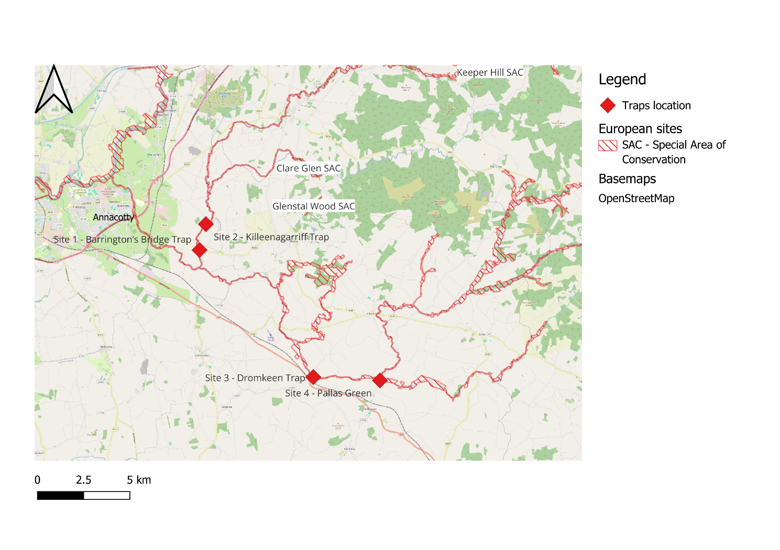
Figure 1: Overview of works area and SAC shown as red hatch layer.

Table 1: Proposed sites and their coordinates.
 | - Name of the proposed site | - Scheme/Watercourse | - Coordinates [Lat/Lon; ITM Easting/Northing]
Site (Trap No.1) | Site 1 – Barrington’s Bridge Trap | Scheme: Mulkear Ballymackeogh  River Slievenohera  C1/1 (chainage 1000-1100) | 52.64494, -8.47503  567852.68, 654965.46
Site (Trap No.1) | Site 2 – Killeenagarriff Trap | Scheme: Mulkear Ballymackeogh  River Slievenohera  C1/1 (chainage 2700 – 2800) | 52.65758, -8.46992  568207.66, 656369.50
Site (Trap No.2) | Site 3 – Dromkeen Trap | River Mulklear  (not a OPW channel on this part of the proposed work) | 52.58333, -8.38337  574019.23, 648073.90
Site (Trap No.2) | Site 4 – Pallas Green | Scheme: Mulkear Cappamore  River Bilboa  C1 (chainage 0) | 52.58186, -8.3302  577621.77, 647892.53

Screening Methodology
The Stage 1 Screening Assessment was conducted closely in line with guidance produced by the Office of Planning Regulator (2021). This methodology is based on source > pathway > receptor chain principles and involves assessing likely significant effects on Natura 2000 sites within the zone of influence of the proposed works. As part of this assessment the works in relation to three main pathways:
1. Water bodies (rivers, streams, marine, groundwater)
2. Land (i.e. proximity to European sites)
3. Air (noise impacts, disruption to migratory paths, e.g. bird and bat species)
The Screening involved assessing the potential impacts of drainage maintenance operations within the arterial drainage scheme, and its zone of influence (ZOI), in relation to each of the three pathways. The ZOI varies for each pathway in order to ensure that only relevant site and impact combinations are considered. Conclusions were then drawn to identify if the bedloads sediments traps within the scheme could impact upon Natura 2000 sites. Sites that had the potential to be impacted by the maintenance works were determined to be within the ZOI and these sites require further assessment.
Impact Assessment Method
The assessment used the source-pathway-receptor model which is a conventional model used for determining the risk of impact to a site or qualifying interest (CIEEM 2018).
Risk is the likelihood or expected frequency of a specified adverse consequence or impact. Applied to the Habitats Directive, it expresses the likelihood of an adverse impact arising as a result of the proposed works and associated activities. The proposed works or activities that may occur as a result of the proposal can be considered a potential hazard. A hazard presents a risk when it is likely to affect something of value (i.e. the Natura 2000 sites and their Qualifying Interests (QIs)). It is the combination of the probability of the hazard of occurring and its consequences that is the basis of a risk assessment which an NIS essentially is:
Risk = probability of an event x consequential damage

The source-pathway-receptor model is a useful tool for determining if a risk is present. In order for a risk to be present, all three elements must be present.
Source: The source considered in this report, is the proposed works or activity that will occur as a result of the works. Key considerations in assessing the source are the nature and scale of the potential impacts that may arise such as the type of contaminants that may arise, the contaminant loading and other physical attributes. The point of occurrence is a critical reference point for assessing the attributes of the Source of any potential adverse impacts.
Pathway: Pathways are established by surface water, groundwater and land and air connections. The pathway includes everything between the source and the receptor; from point of release of potential adverse impacts, such as contaminants, to the receptor. The location, nature, connectivity and extent of wells, groundwater dependent ecosystems, aquifers and faults can all influence the nature of a pathway. Rivers, streams and drainage ditches could all act as potential pathways for potential waterborne impacts. Land and air pathways to be considered include those that may transfer direct physical impacts, noise and visual disturbance (vibrations) and dust or other airborne particles.
Receptor: The receptor is the qualifying interests of the relevant Natura 2000 sites, their Conservation Objectives (COs) and the overall integrity of the Natura 2000 sites. While the competent authority should only agree to the plan or project after having ascertained that it will not adversely affect the integrity of the site concerned. In order to determine the significance of any potential adverse impacts that may occur that may adversely affect the integrity of the Natura 2000 site, the COs of each site are assessed relative to the potential impacts that may occur as a result of the proposed works. Detailed site-specific COs are available for the Natura 2000 sites considered in this screening assessment, and they are available in the CO document for each site on the NPWS website.
The overall aim of COs is to maintain or restore the favorable conservation conditions of the Annex I habitats and/or the Annex II species for which a SAC or SPA has been selected, under which the site-specific objectives contain more detailed attributes, measures and targets. There are a set of generic COs for species and habitats. For some sites these have been developed into site-specific objectives.

Project description

Construction Methodology
The installation of the traps has been subject to a method statement to allow for the assessment of potential impacts. Munster Technological University (MTU) proposes to install two small steel bedload sediment traps within the Mulkear catchment as part of the Interreg North-West Europe ClimASed project. The purpose of the traps is to collect samples of sediment moving along the riverbed. The samples will provide information on the quantity of bed sediment transported, the particle-size distribution of the transported material, the differences in sediment movement between locations, and changes in sediment transport under different flow conditions. The equipment is intended solely for scientific monitoring. All works carried out during this project will be undertaken in accordance with Inland Fisheries Ireland; Guidelines on protection of fisheries during construction works in and adjacent to waters. The works will not involve channel diversion, water-level control or permanent alteration of the river and it will be coordinate by MTU. See Appendix A for detailed Method Statement.

Site Descriptions
The proposed locations were visited and inspected by Aline O’Connell, Environmental Scientist from OPW Environment Section on the 19/08/2026. The general conditions have been recorded within the area of works. The works are occurring within the Lower River Shannon SAC and the two bedload sediment traps proposed are within the Mulkear catchment. Around of the site 1 – Barrington’s Bridge were identified Non Native Invasive Species Giant hogweed (Heracleum mantegazzianum). Around the site 2 – Killeenagarriff were identified Non Native Invasive Species Giant hogweed and Japanese Knotweed (Fallopia japonica). Around the location of the site 3 – Dromkeen Trap, were identified Invasive Species Giant Hogweed and Japanese Knotweed however on the site 4 – Pallas Green, according to the OPW records, were identified Himalayan balsam (Impatiens glandulifera) and Japanese Knotweed. All these invasive plants were located outside the river channel. A review of historical OPW records show that lamprey on the site 1, 3 and 4 of the proposed works. The surrounding habitat is represented, in your majority, by Improved Grasslands, Wet Grasslands and Amenity Grasslands. Hedgerows and Treelines. Buildings, ways and other artificial surfaces are the Built land which represents a small part of the area. There will be no tree or scrub removal as part of the works.
Access to the traps location will be through local access from R506 to site 1 and 2 and the access to the site 3 and 4 is through N24. See (Appendix B) for more detail on site access, construction methods, etc. The final position of each trap will be confirmed during a site inspection by the MTU. Where water depth, flow, substrate, safe access and ecological conditions allow, each trap will preferably be positioned near the centre of the active wetted channel. This is intended to provide a representative sample of material transported through the principal flow area.
Where installation in the centre of the channel is not practical, the trap will be positioned as close as reasonably possible to the central active-flow zone while maintaining safe access, trap stability and unobstructed fish passage. The works must stop where sensitive habitat, spawning activity, protected fauna or an unexpected ecological constraint is identified during the progressing of the works.
Below the figures 2-5 are showing the habitats delimited for each location proposed for the traps. (Source: National Land Cover Map for Ireland (2018).

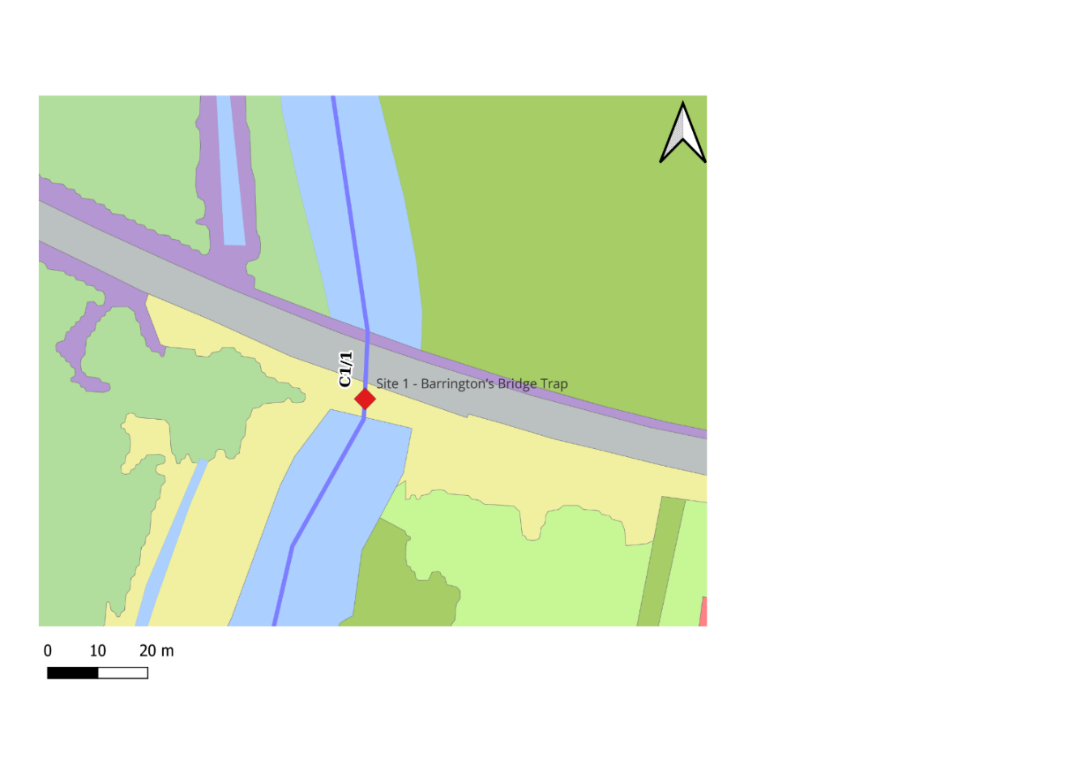
Legend
Site 1 – Barrington’s Bridge Trap location
Habitat Mapping
Wet Grassland
Improved Grassland
Amenity Grassland
Hedgerows
Rivers and stream
Ways
Treelines
Opw Scheme Channels
Basemaps
Bing Aerial
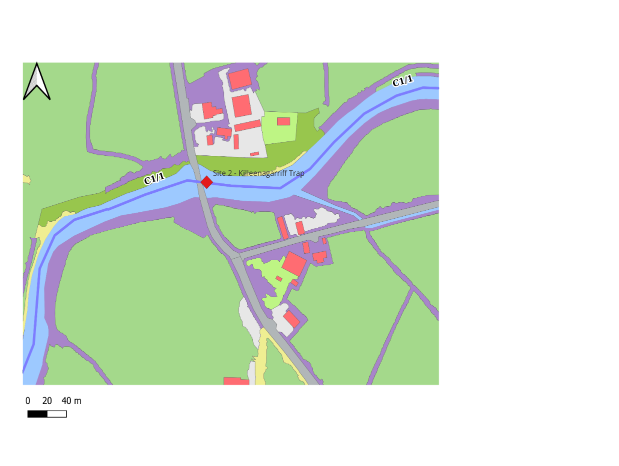
Legend
Site 2 –Killeenagarriff Trap location
Habitat Mapping
Wet Grassland
Improved Grassland
Amenity Grassland
Hedgerows
Rivers and stream
Ways
Treelines
Opw Scheme Channels
Basemaps
Bing Aerial
Buildings
Other artificial surfaces

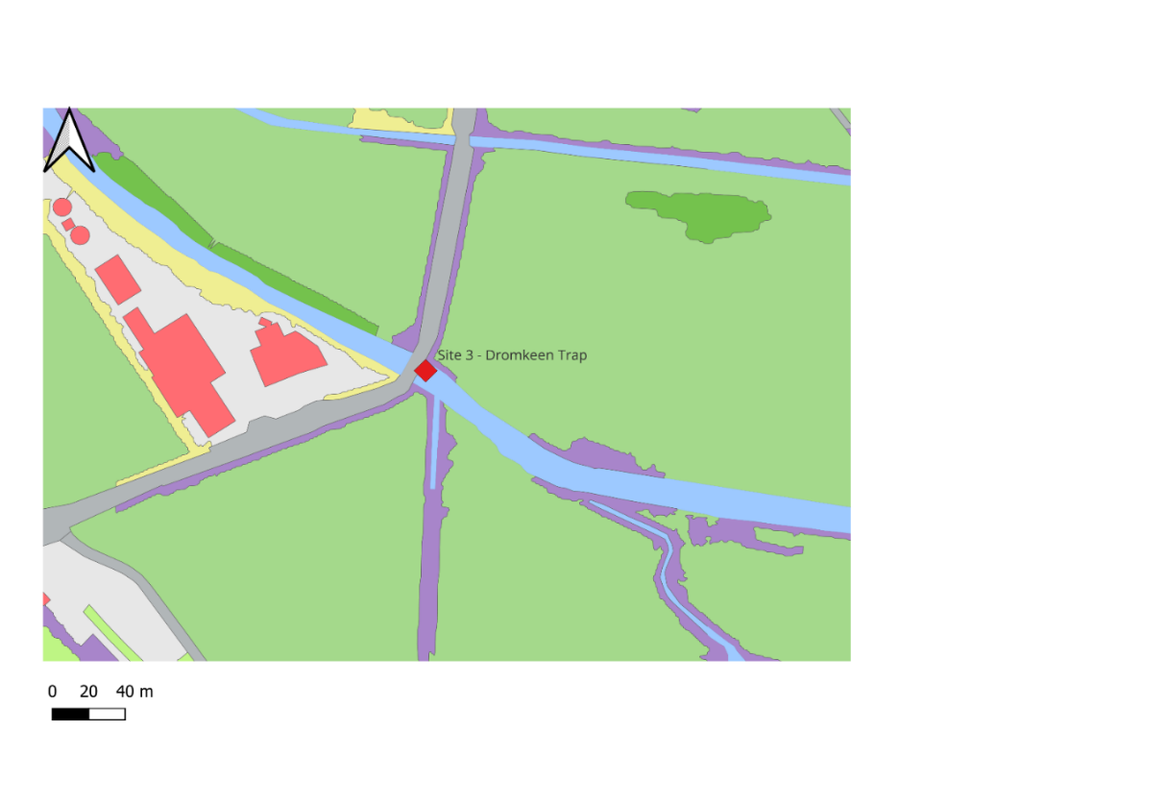
Legend
Site 3 – Dromkeen Trap location
Habitat Mapping
Wet Grassland
Improved Grassland
Amenity Grassland
Hedgerows
Rivers and stream
Ways
Treelines
Basemaps
Bing Aerial
Buildings
Other artificial surfaces
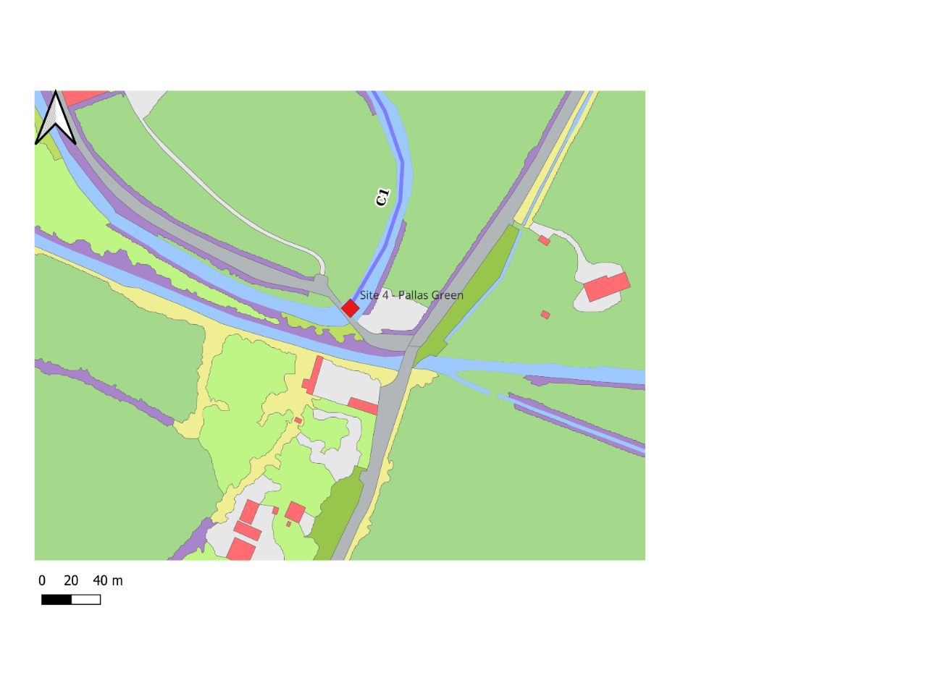
Legend
Site 4 – Pallas Green Trap location
Habitat Mapping
Wet Grassland
Improved Grassland
Amenity Grassland
Hedgerows
Rivers and stream
Ways
Treelines
Basemaps
Bing Aerial
Buildings
Other artificial surfaces
Opw Scheme Channels

Installation Procedure
Before installation, MTU will confirm access permission, weather conditions, river levels and the precise installation position.
The installation procedure will be as follows:
- Personnel will access the river using an existing bank or access route.
- The trap and hand tools will be carried manually to the installation point.
- The preferred installation position will be near the center of the active wetted channel, where site and safety conditions permit.
- The precise footprint will be photographed and inspected before disturbance.
- A small recess, limited to the dimensions of the trap, will be prepared manually using hand tools.
- Riverbed material will be carefully removed and retained beside the working area.
- The trap will be lowered manually into the recess, with its entrance facing upstream.
- The top and entrance of the trap will be positioned approximately flush with the surrounding riverbed.
- The trap will be secured using metal pins if needed.
- Retained bed material will be carefully placed around the sides of the trap where required.
- The completed installation will be photographed and its coordinates recorded.
No machinery will enter the river, and no concrete, cement, grout, resin or chemical fixing material will be used. The installation date will be agreed with IFI, taking account of its guidance regarding the timing of instream works in fisheries channels.
Both traps are temporary monitoring installations and will be removed when the monitoring programme is complete. On this part the project the traps will be manually lifted from the riverbed. All fixings and artificial materials will be removed. The resulting recess will be reinstated using the original riverbed material, as far as practicable, and the bed will be returned to a profile consistent with the surrounding channel. Photographs will be taken following removal and reinstatement
As there is presence of invasive non-native plant and aquatic species it is imperative that the installation team/site visitors implement strict high bio-security protocols when entering and exiting sites and at a minimum adopt the Check/Clean/Dry approach.

Table 2. Proposed works site description

- Location | - Watercourse | - Site Description | - Site Photo
Site 1 - Barringtons Bridge | River Slievenohera  Scheme: Mulkear Ballymackeogh | Channel C1/1 (chainage 1000-1100) is within the Lower River Shannon SAC (002165) on the River Slievenohera. The river is approximately 12m wide. The channel has a flat gradient. River is low flowing and varies in depth but was at a maximum 0.5m deep at time of survey. Were identified invasive species Giant Hogweed during the site survey. | 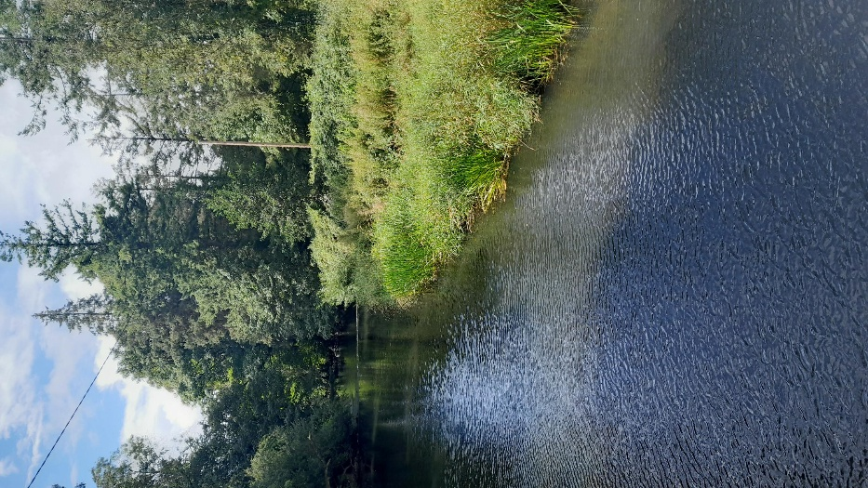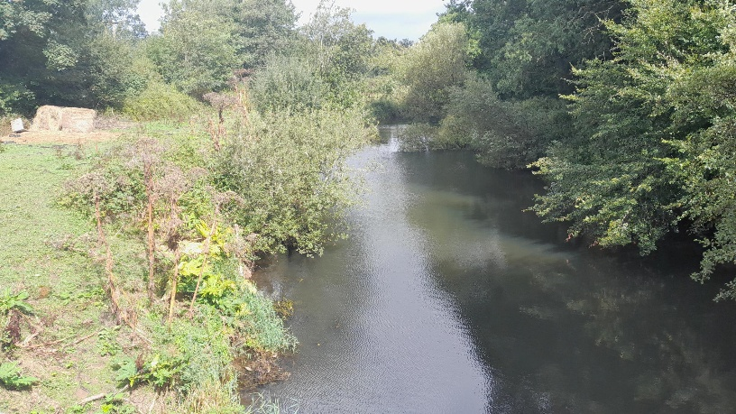
Site 2 - Killeenagarriff Trap | River Slievenohera  Scheme: Mulkear Ballymackeogh | Channel C1/1 (chainage 2700 -2800) is within the Lower River Shannon SAC (002165) on the River Slievenohera. The river is approximately 20m wide at the bridge. The channel has a flat gradient. River is low flowing and varies in depth but was at a maximum 1.0m deep at time of survey. Were identified invasive species Giant Hogweed and Japanese Knotweed during the site survey. | 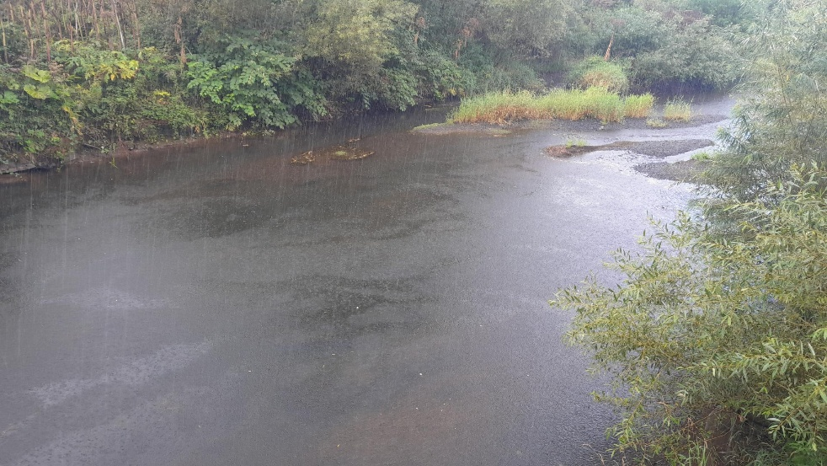  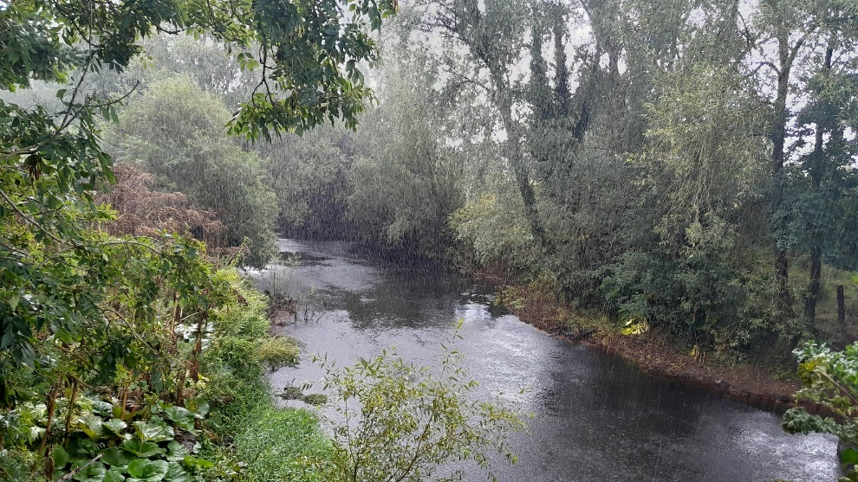
Site 3 - Dromkeen Trap | River Mulklear  (not a OPW channel on this part of the proposed work | This channel is within the Lower River Shannon SAC (002165) on the River Mulkear. The river is approximately 8m wide at the bridge. The channel has a flat gradient. River is low flowing and varies in depth but was at a maximum 0.30 deep at time of survey. Were identified invasive species Giant Hogweed and Japanese Knotweed during the site survey. | 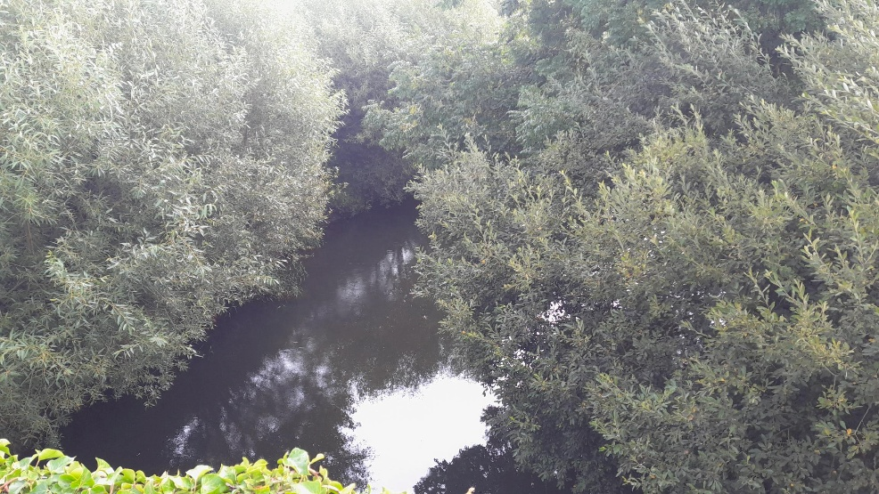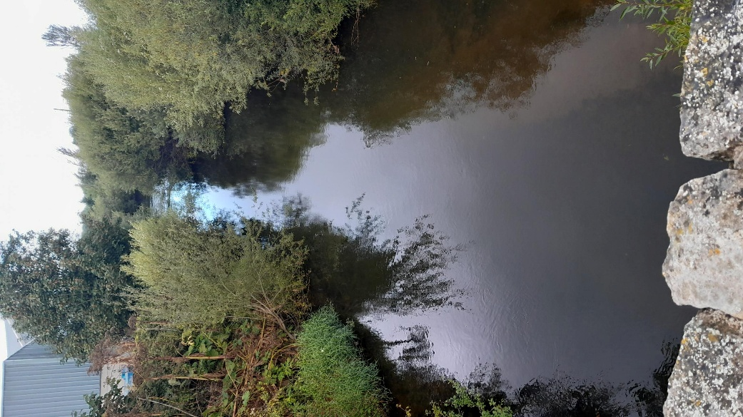
Site 4 – Pallas Green | Scheme: Mulkear Cappamore  River Bilboa  C1 (chainage 0) | Channel C1 (Chainage 0) is within the Lower River Shannon SAC (002165) on the River Bilboa. The river is approximately 6m wide at the bridge. The channel has a flat gradient. River is low flowing and varies in depth but was at a maximum 0.30m deep at time of survey. According to the OPW records, were identified invasive species Himalayan Balsam and Japanese Knotweed. | 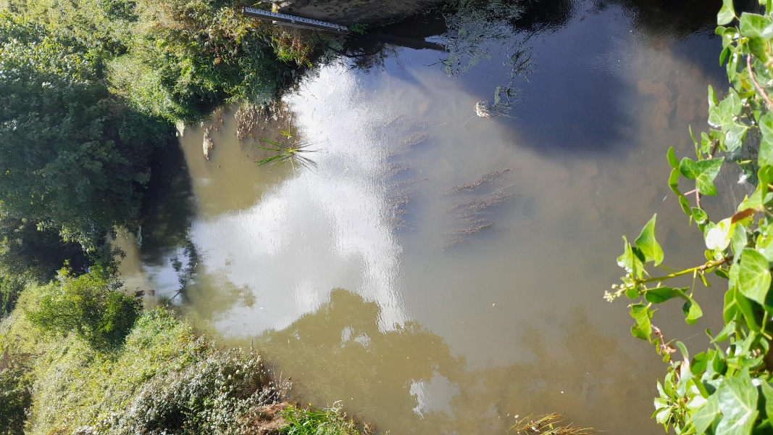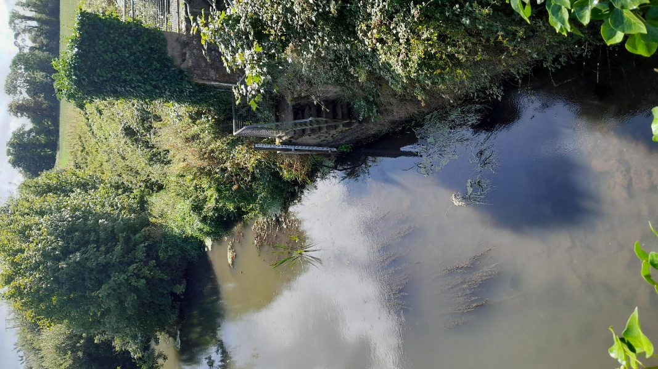

Screening for Appropriate Assessment: European (Natura 2000) Sites and the Potential for Significant Effects

Screening Assessment of Natura 2000 Sites
Table 4.1 provides location details for the two bedload sediment traps proposed for installation by MTU and of the assessment of potential surface water, groundwater, land and air pathways between the works and European Sites.
The following European Sites are in proximity or linked by surface water, groundwater, land and air to the proposed works:
- Lower River Shannon SAC (002165)

The Qualifying Interests and Conservation Objectives for the European Sites with potential links to the proposed works sites are set out in Table 3. While there is potential for some of the species described on OPW records (lamprey) and habitats to occur at the proposed works sites, the site visit conducted and description in Table 2 has not identified the presence of these species or habitats within the works zone of influence and therefore has not identified any likely significant effects on European Sites as a result of works described in the appended construction method statement for the site (Appendix B).
Table 3: European Sites – Qualifying Interests and Conservation Objective
European Site | Qualifying Interests | Conservation Objectives
Lower River Shannon SAC (002165) | Sandbanks which are slightly covered by sea water all the time [1110]  Estuaries [1130]  Mudflats and sandflats not covered by seawater at low tide [1140]  Coastal lagoons [1150]  Large shallow inlets and bays [1160]  Reefs [1170]  Perennial vegetation of stony banks [1220]  Vegetated sea cliffs of the Atlantic and Baltic coasts [1230]  Salicornia and other annuals colonising mud and sand [1310]  Atlantic salt meadows (Glauco-Puccinellietalia maritimae) [1330]  Mediterranean salt meadows (Juncetalia maritimi) [1410]  Water courses of plain to montane levels with the Ranunculion fluitantis and Callitricho-Batrachion vegetation [3260]  Molinia meadows on calcareous, peaty or clayey-silt-laden soils (Molinion caeruleae) [6410]  Alluvial forests with Alnus glutinosa and Fraxinus excelsior (Alno-Padion, Alnion incanae, Salicion albae) [91E0]  Margaritifera margaritifera (Freshwater Pearl Mussel) [1029]  Petromyzon marinus (Sea Lamprey) [1095]  Lampetra planeri (Brook Lamprey) [1096]  Lampetra fluviatilis (River Lamprey) [1099]  Salmo salar (Salmon) [1106]  Tursiops truncatus (Common Bottlenose Dolphin) [1349]  Lutra lutra (Otter) [1355]  Sources: NPWS (2012) Conservation Objectives: Lower River Shannon SAC (002165) Version 1. National Parks and Wildlife Service, Department of Housing, Local Government and Heritage. | To maintain or restore the favorable conservation condition of the listed species and habitats.

Table 4 provides details of the AA screening and an assessment of the potential for likely significant effects on European sites within the ZOI based on the source-pathway-receptor model.

Project No. | Drainage Scheme | Channel & Embankment Ref. | European Site & Code | Surface Water Catchment | Surface Water Pathway | Land & Air Pathway | Potential for Likely Significant Effects - Screened In/Out for further assessment
Site 1 – Barrington’s Bridge Trap | Mulkear Ballymackeogh | River Slievenohera  C1/1 (chainage 1000-1100) | Lower River Shannon SAC (002165) | Mulkear catchment | Yes, within Lower River Shannon SAC. | Yes, site within Lower River Shannon SAC | No likely significant effect/ Screened out for further assessment.
Site 2 – Killeenagarriff Trap | Mulkear Ballymackeogh | River Slievenohera  C1/1 (chainage 2700 – 2800) | Lower River Shannon SAC (002165) | Mulkear catchment | Yes, within Lower River Shannon SAC. | Yes, site within Lower River Shannon SAC | No likely significant effect/ Screened out for further assessment.
Site 3 – Dromkeen Trap | Not within a drainage scheme | River Mulklear | Lower River Shannon SAC (002165) | Mulkear catchment | Yes, within Lower River Shannon SAC. | Yes, site within Lower River Shannon SAC | No likely significant effect/ Screened out for further assessment.
Site 4 – Pallas Green | Mulkear Cappamore | River Bilboa – C1 (chainage 0) | Lower River Shannon SAC (002165) | Mulkear catchment | Yes, within Lower River Shannon SAC. | Yes, site within Lower River Shannon SAC | No likely significant effect/ Screened out for further assessment.

Assessment of Potential Impact on European Sites to installation of two river bed traps (temporally works)

5.2.1 Mulkear Ballymackeogh and Mulkear CaPpamore
Source Receptor Pathway:
- Distance from Lower River Shannon SAC – within SAC
Summary of Proposed Works
The purpose of the traps is to collect samples of sediment moving along the riverbed. The samples will provide information on:
- Quantity of bed sediment transported;
- Particle-size distribution of the transported material;
- Differences in sediment movement between locations;
- Changes in sediment transport under different flow conditions.
Two identical welded mild steel bedload sediment traps will be installed. Each trap comprises an open-topped rectangular collection chamber, a flared upstream entrance apron and four welded fixing lugs through which metal securing pins may be inserted, where required.
The traps are constructed entirely from bare mild steel. They are unpainted, ungalvanised and uncoated, and no protective coating, preservative, resin, sealant or other chemical treatment has been applied to the steel surfaces. Before installation, each trap will be cleaned, thoroughly rinsed and allowed to air-dry so that no cleaning-agent residue remains. The traps will operate passively and will contain no electrical equipment, moving parts, screens or chemicals. The equipment is intended solely for scientific monitoring.
For more information regarding installation procedure, inspection and sediment collection see Appendix B for method statement.
Surrounding habitat is mostly improved grassland, wet and amenity grasslands, treelines, hedgerows, and built land (BL3). Were identified during the site visit and according to the OPW records: Giant hogweed, Japanese knotweed and Himalayan Balsam. The works will not involve channel diversion, water-level control or permanent alteration of the river. Installation will take place on dates agreed with OPW and Inland Fisheries Ireland and only after completion of the required environmental assessment and approval process. The works will be postponed during high or rising river levels, heavy rainfall or unsuitable ecological or safety conditions.

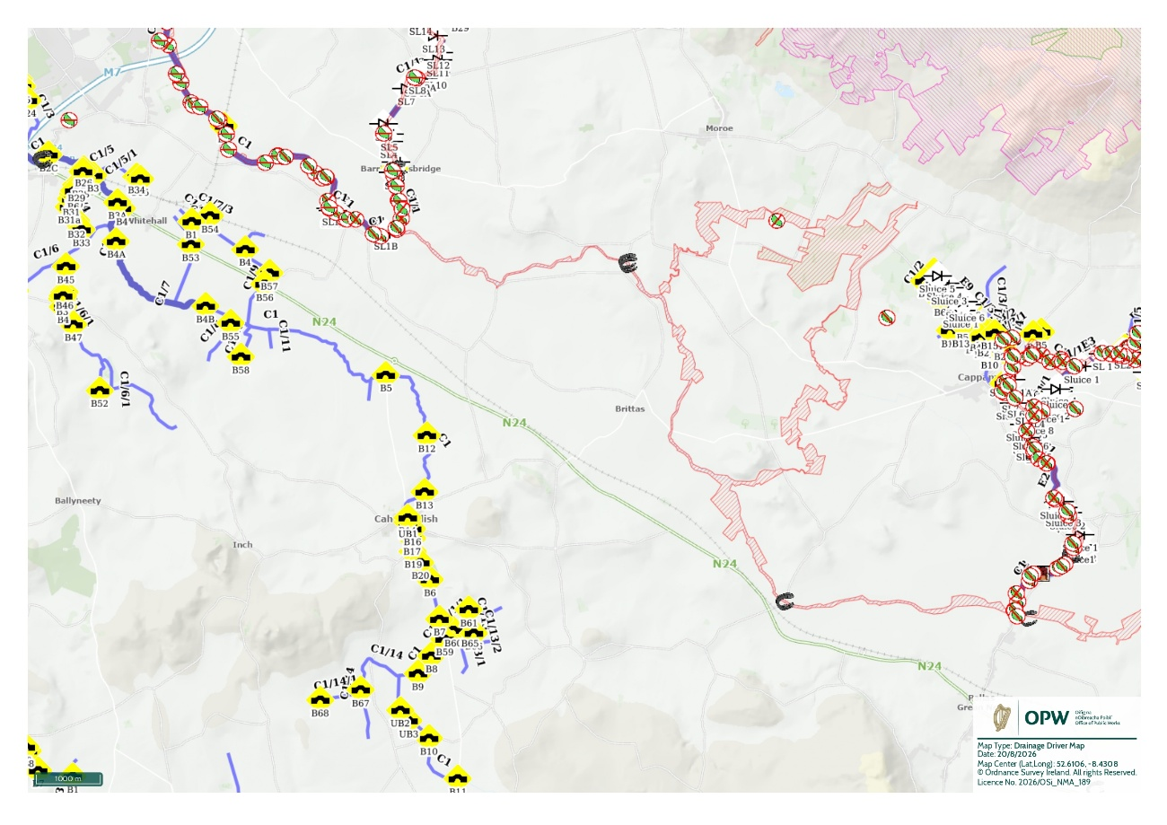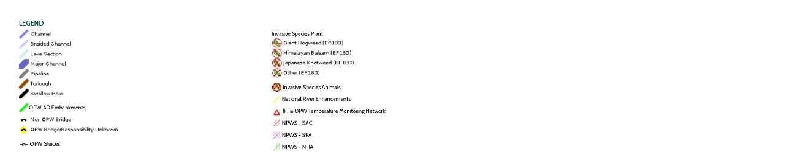
Site 4
Site 3
Site 1
Site 2

Figure 6: Map showing the proposed 4 site locations to install the 2 traps and the SAC/ in proximity to works area on OPW Data hub maps with environmental layer turned on.

The conservation objectives for which Lower River Shannon SAC (002165) are designated and which are found within the receiving environment as well as the potential impact of the works on each of the qualifying interests are listed in Table 4.3.
Table 5: Lower River Shannon SAC Screening Assessment for installation of two bedload sediments traps on Mulkear catchment.
Qualifying Interest | Proximity to the works/Conservation Objectives (co) | Potential for Impact | Screening Conclusion
1029 Freshwater Pearl Mussel (FWPM) | SAC CO is approx. 55km to site 1, 55.5km to site 2, 61.5km site 3 and 65km to site 4 distance. FWPM habitat is not hydrologically linked | The conservation objective for fresh water pearl mussel in the Lower River Shannon SAC are confined to the Cloon River in County Clare only. There is no hydrological pathway for FWPM between the Cloon River and the channel C1 located adjacent to the works. C1 are not identified as within a Freshwater Pearl Mussel Catchment and no records present of the species within the channel.  There is no perceptible impact on Freshwater Pearl Mussel within the SAC as a result of the works. | No likelihood of significant effect
91E0 Alluvial forests with Alnus glutinosa and Fraxinus excelsior (Alno-Padion, Alnion incanae, Salicion albae)* | SAC CO. > works location within SAC | This Habitat type is located in the upper parts of the SAC (in NPWS CO mapping) but may also be present in other areas outside of these within the SAC. This Habitat type was not identified during the site walkover.  The site survey identified the riverbank habitat is bordered by improved agricultural grassland and built land. There will be no tree or scrub removal. Given the nature and scale of the works; the works will not impact linkages between wet woodland Habitat Types. The channel is well vegetated. The proposed works will not result in significant silt and pollution runoff to impact this Habitat type in the vicinity, downstream or via groundwater pathways. There is no perceptible impact on as a result of the works to this Habitat type. The release of small quantities of silt into the channel; will not affect the Conservation Objectives of this Habitat types | No likelihood of significant effect
6410 Molinia meadows on calcareous, peaty or clayey-silt-laden soils (Molinion caeruleae) | SAC CO is approx. 9.5km to site 1; 8km to site 2; 15km to site 3 and 18km to site 4.  Habitat is not hydrologically linked. | This Habitat type is located in the upper parts of the SAC (NPWS CO habitat mapping) outside the zone of influence for this project. This Habitat type was not identified during the site walkover. The surrounding land consists improved agricultural land in your majority and some build land. The proposed works will not result in significant silt and pollution runoff to impact this Habitat type in the vicinity, downstream or via groundwater pathways. There is no perceptible impact on as a result of the works to this Habitat type. The release of small quantities of silt into the channel will not affect the Conservation Objectives of these Habitat types | No likelihood of significant effect
3260 Water courses of plain to montane levels with the Ranunculion fluitantis and Callitricho-Batrachion vegetation | SAC CO >works area within SAC | These Habitat types are located in the upper parts of the SAC according to NPWS habitat maps but may be present in other areas. The channels may support conditions for this Habitat type in stream given the substrate type. However, this Habitat type was not identified during the site walkover in proximity to the works. The proposed works will not result in significant silt and pollution runoff to impact this Habitat type in the vicinity, downstream or via groundwater pathways. There is no perceptible impact on as a result of the works to this Habitat type. The release of small quantities of silt into the channel; will not affect the Conservation Objectives of these Habitat type | No likelihood of significant effect
1220 Perennial vegetation of stony banks | SAC CO > 62km to site 1; 63.8km to site 2; 69km to site 3; 74km to site 4. | While there are areas of these Habitat types within the lower parts of the SAC, there are none in close proximity to the works. The habitat survey has not identified these habitats as being present within the project area or directly downstream. The proposed works will not result in significant silt and pollution runoff to impact these Habitat types in the estuary, downstream or via groundwater pathways. There is no perceptible impact on as a result of the works to these Habitat types. The release of small quantities of silt into the channel; will not affect the Conservation Objectives of these Habitat types. | No likelihood of significant effect
1230 Vegetated sea cliffs of the Atlantic and Baltic coasts | SAC CO > 62km to site 1; 63.8km to site 2; 69km to site 3; 74km to site 4. |  | No likelihood of significant effect
1096 Sea Lamprey | SAC CO >works within SAC | There are records of lamprey on the channels on all these locations on OPW maps. The proposed works area is within the SAC. The Mulkear is known to hold substantial populations of Sea Lamprey (Mulkear LIFE. 2022). The others channels: Slievenohera and Bilboa are connected and also are recorded with substantial lamprey population, according to OPW records. The conservation objectives for Sea Lamprey identify barriers to lamprey migration to the upper extent of the SAC within the estuary and on the Mulkear River. Spawning lamprey require clean gravels and although ammnocoetes require fine sediment, they reach these areas by being washed downstream. Considering the nature of the proposed works and on the Mulkear River within the SAC; it is unlikely that Sea lamprey will be affected by the proposed two bedloads.  It’s recommended to the works are being carried outside Sea lamprey spawning season. Due to the nature of the works, that they will occur in the low flowing drainage channel, the proposed works will not result in significant silt and pollution runoff that has the potential to impact on sea lamprey in the immediate vicinity or downstream. Any arising sediment will be negligible and largely settled within proximity to the proposed works in the SAC. There is no perceptible impact on Sea Lamprey within the SAC as a result of the works. | No likelihood of significant effect
1096 Brook Lamprey | SAC CO > works within SAC | There are records of lamprey on the channels on all these locations on OPW maps. The proposed works area is within the SAC. The Mulkear is known to hold substantial populations of Sea Lamprey (Mulkear LIFE. 2022). The others channels: Slievenohera and Bilboa are connected and also are recorded with substantial lamprey population, according to OPW records. The conservation objectives for Sea Lamprey identify barriers to lamprey migration to the upper extent of the SAC within the estuary and on the Mulkear River. Spawning lamprey require clean gravels and although ammnocoetes require fine sediment, they reach these areas by being washed downstream. Considering the nature of the proposed works and on the Mulkear River within the SAC; it is unlikely that Sea lamprey will be affected by the proposed two bedloads.  It’s recommended to the works are being carried outside Sea lamprey spawning season. Due to the nature of the works, that they will occur in the low flowing drainage channel, the proposed works will not result in significant silt and pollution runoff that has the potential to impact on sea lamprey in the immediate vicinity or downstream. Any arising sediment will be negligible and largely settled within proximity to the proposed works in the SAC. There is no perceptible impact on Sea Lamprey within the SAC as a result of the works. | No likelihood of significant effect
1099 River Lamprey | SAC CO > works within SAC | It’s recommended to the works are being carried outside Sea lamprey spawning season. Due to the nature of the works, that they will occur in the low flowing drainage channel, the proposed works will not result in significant silt and pollution runoff that has the potential to impact on sea lamprey in the immediate vicinity or downstream. Any arising sediment will be negligible and largely settled within proximity to the proposed works in the SAC. There is no perceptible impact on Sea Lamprey within the SAC as a result of the works. | No likelihood of significant effect
1106 Atlantic Salmon | SAC CO > works within SAC. | This channel has been be identified as a fisheries and spawning channel for salmon in proximity to the works (Mulkear LIFE, 2022). It’s recommended to start the works out of the spawning season.  The works will occur at low flows. The channel bed substrate is composed of fine gravel substrate.  Due the nature of the proposed works and that occur al low flows and during a short period, the proposed works will not result in significant silt and pollution runoff to impact on salmon in the immediate vicinity or downstream as the works will take place. Any arising sediment will be negligible and largely settled in proximity to the works within the SAC. There is no perceptible impact on Salmon within the as a result of the works.  There is no perceptible impact on Salmon within the SAC as a result of the works. | No likelihood of significant effect
1355 Otter | SAC CO > works within SAC | Otters may use the nearby riparian habitat and instream channel for foraging and commuting purposes. The works are to be undertaken instream and for a short period. There is no suitable habitat in proximity to the works for otter holts, couches or lies. There will be no disturbance of otters as a result of the works which will be limited period. The proposed works will not result in significant silt and pollution runoff to impact on otter in the immediate vicinity or downstream. There is no perceptible impact on Otter within the SAC as a result of the works. | No likelihood of significant effect
349 Bottlenose Dolphin | SAC CO > works within SAC | Bottlenose Dolphin is a marine species known to use the Shannon estuary. The River Shannon estuary is connected to channels and the works location at a distance of approx. 6km for site 1 and 2; and 17km and 15 km to site 3 and 4 respectively downstream. The site conservation objectives identify Bottlenose Dolphin a Species of marine environments. The freshwater habitat of channels does not provide habitat to support Bottlenose Dolphin. Considering the lack of suitable habitat, intervening distance and barriers identified in the conservation objectives on the Mulkear. The works area is inaccessible for Bottlenose dolphin. Works will not result in significant silt and pollution runoff downstream as works will occur in the dry and the channel is of a low gradient and is well vegetated. There will be minimal release of sediment as a result of the proposed works. .  There is no perceptible impact on Bottlenose Dolphin within the SAC as a result of the works. | No likelihood of significant effect
1110 Sandbanks which are slightly covered by water all the time | SAC CO >83km to site 1, 82km to site 2; 87km to site 3; 91km to site 4 distance | While there are areas of Sandbanks which are slightly covered by water all the time. There are none in close proximity to the works, with the nearest 82km from the works. There is no perceptible impact on Sandbanks which are slightly covered by water all the time within the SAC as a result of the works. | No likelihood of significant effect
1130 Estuaries | SAC CO > works within SAC 10km to site 1; 10.6km to site 2; 18.7km to site 3; 22km to site 4. upstream of Shannon Estuary | The Shannon Estuary is located at least 10km downstream of the works location within the SAC. Given the nature and scale of the works the works will not result in significant silt and pollution runoff. Estuaries are accustomed to fluctuation in silts and sediments due to ongoing tidal cycle’s characteristic of this Habitat type. There is no perceptible impact on Estuaries within the SAC as a result of the works. | No likelihood of significant effect
1140 Mudlflats and Sandflats not covered by seawater at low tide | SAC CO > approx. 8km to site 1, 8.7km to site 2; 14.2km to site 3 and 17.7km to site 4. | While there are areas of Mudlflats and Sandflats not covered by seawater at low tide there are none in proximity to the works. In addition to this, Mudflats and Sandflats are accustomed to fluctuation in silts and sediments due to ongoing tidal cycles. Deposition of silts and sediments as a result of tidal cycles are characteristic of this Habitat type. There is no perceptible impact on Mudlflats and Sandflats not covered by seawater at low tide within the SAC as a result of the works. | No likelihood of significant effect
1150 *Coastal lagoons | SAC CO > 78km to site 1; 78.6km to site 2; 84km to site 3 and 87.5km to site 4. | While there are areas of Coastal Lagoons within the SAC there are none in close proximity to the works. The nearest lagoon according to the SAC conservation objectives is located 78km distance from the works on the opposite side of the Estuary. Works will not result in significant silt and pollution runoff. There is no perceptible impact on Coastal Lagoons within the SAC as a result of the works. | No likelihood of significant effect
1160 Large shallow inlets and bays | SAC CO > 69km to site 1; 68.7km to site 2; 74km to site 3 and 77.6km to site 4. | While there are areas of large and shallow inlets and bays within the SAC there are none in close proximity to the works, with the closest is approx. 69km from the works. There is no perceptible impact on large and shallow inlets and bays within the SAC as a result of the works. | No likelihood of significant effect
1170 Reefs | SAC CO >28km to site 1; 28.2km to site 2; 35.4km to site 3; 38.9km to site 4. | While there are areas of Reefs within the SAC there are none in close proximity to the works, with the closest approx. 28km from the works. Considering the intervening distance, the nature of the intervening channel – that it is an expansive estuarine habitat and dilution effects will occur, and the nature of the proposed works, there is no perceptible impact on Reefs within the SAC as a result of the works. | No likelihood of significant effect
1310 Salicornia and other annuals colonizing mud and sand | SAC CO >unknown | While there are areas of Salicornia and other annuals colonizing mud and sand within the SAC there are none in close proximity to the works. This Habitat Type occurs in marine environments according to the site conservation objectives. The Shannon Estuary is at a distance of 10km downstream of the works. There may be further unmapped areas within the Shannon estuary. Considering the intervening distance, the nature of the intervening channel – that it is an expansive estuarine habitat and dilution effects will occur, and the nature of the proposed works, there is no perceptible impact on Salicornia and other annuals colonizing mud and sand within the SAC as a result of the works. | No likelihood of significant effect
1330 Atlantic salt meadows (Glauco-Puccinellietalia maritimae) | SAC CO > 20km to site 1; 20.5km to site 2; 28km to site 3; 31.5km to site 4. | This habitat has been mapped as being present within the SAC in the Shannon Estuary outside of the area of works. There may be further unmapped areas of this habitat within the Shannon Estuary. Considering the intervening distance, the nature of the intervening channels, the expansive estuarine habitat and dilution effects will occur, and the nature of the proposed works, there is no perceptible impact on Atlantic salt meadows (Glauco-Puccinellietalia maritimae) within the SAC as a result of the works. | No likelihood of significant effect
1410 Mediterranean salt meadows (Juncetalia maritimi) | SAC CO. > 21.6km to site 1; 21.8km to site 2; 29.5km to site 3; 32.9km to site 4. | This habitat has been mapped as being present within the SAC in the Shannon Estuary outside of the area of works. There may be further unmapped areas of this habitat within the Shannon Estuary. Considering the intervening distance, the nature of the intervening channel, the expansive estuarine habitat and dilution effects will occur, and the nature of the proposed works. There is no perceptible impact on Mediterranean salt meadows (Juncetalia maritimi) within the SAC as a result of the works. | No likelihood of significant effect

4.3 Cumulative and in-combination Impacts
It is a requirement of Appropriate Assessment that the cumulative or in-combination effects of the proposed development together with other plans or projects are assessed.
The following sources were consulted in order to determine if there were any other plans or projects in the area which could result in cumulative impacts:
- DHPLG EIA Portal https://www.housing.gov.ie/planning/environmental-assessment/environmental-impact-assessment-eia/eia-portal
- Limerick- Planning System https://www.eplanning.ie/LimerickCCC/searchtypes
The project is located outside of Limericks planned area for Wind Energy Development (Limerick Development Plan Limerick Development Plan 2022 – 2028, Local Authority Climate Action Plan 2024 - 2029). The effects that may occur as a result of the proposed works occurring concurrently with cyclical arterial drainage management works and normal agricultural farming have been considered. Installation will take place on dates agreed with OPW and Inland Fisheries Ireland and only after completion of the required environmental assessment and approval process. Work will be postponed during high or rising river levels, heavy rainfall or unsuitable ecological or safety conditions. The final position of each trap will be confirmed during a site inspection. Where water depth, flow, substrate, safe access and ecological conditions allow, each trap will preferably be positioned near the centre of the active wetted channel. This is intended to provide a representative sample of material transported through the principal flow area. No machinery will enter the river, and no concrete, cement, grout, resin or chemical fixing material will be used. The installation date will be agreed with IFI, taking account of its guidance regarding the timing of instream works in fisheries channels. It is reasonable to conclude, that the proposed project, either individually or in combination with other plans or projects would not be likely to result in significant effects on the Lower River Shannon SAC

5 CONCLUSION
The Appropriate Assessment Screening has considered and assessed the likely impacts of the proposed installation of two bedloads of sediments trap on the following European sites.
- Lower River Shannon SAC (002165)

In consideration of the proximity of the works site and the European sites: Lower River Shannon SAC; the timing, the scale and the duration of the works, the construction methods, and the settlement and dilution factor due to separation distance in the event of any silt discharges, it is reasonable to conclude that there is no perceptible likely significant effect on the integrity and Conservation Objectives of these European Sites alone and in combination with other plans and projects as a result of the works.
In view of best scientific evidence and the basis of objective information, it is concluded that the proposed installation of two bedloads of sediments trap on the Mulkear Catchment, on any of the 4 sites requested for this assessment individually or in-combination with other plans or projects, will not have a significant effect on the above listed European Sites, in view of the sites’ conservation objectives and qualifying interests. Therefore, an Appropriate Assessment of the works in relation to the above European sites is not required. The works are screened out in relation to the above European sites.

Appendix A – Bedload sediments trap

Appendix B – Method Statements
See:
Method Statement - Sediment Traps VH_BB2.docx

